



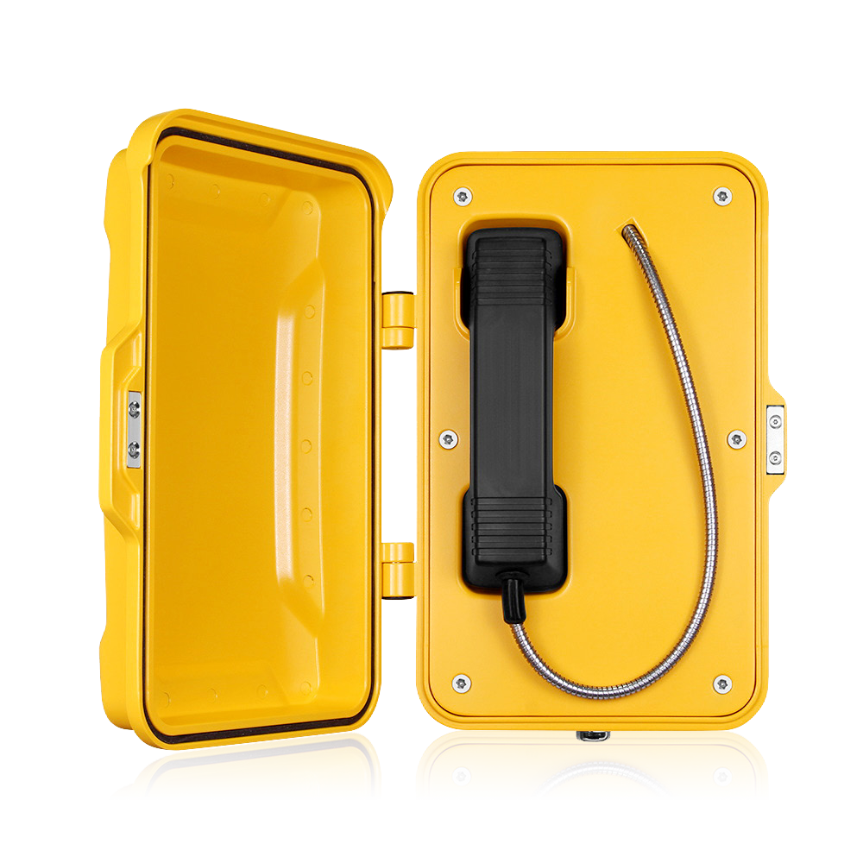
JR101-CB-4G
- Aluminum alloy die-casting body
- Protection level IP66/IP67
- Advanced noise reduction technology for HD calls
- Corrosion-resistant hardware
- CE, FCC, RoHS, IK10, IP67, ISO9001 standards
IP67
IK10
HD
Waterproof Telephone

MAIN FEATURES

It was designed for public and industrial areas requiring a virtually indestructible telephone. The housing is made of die-cast aluminum alloy, with a weatherproof enclosure and an exterior polyurethane finish. It is designed to withstand high levels of humidity, dust, vibration, shock, extreme temperatures, (salt)water, abuse or attempted vandalism.
Typical applications include Outdoor Environments, Public Highways, Underground Tunnels / Mining, Offshore Wind Farms, Production Floors, Chemical Processing Sites, Power Stations or inside large Lifting Machinery such as Quayside Container Cranes, Rubber-Tyred Gantry Cranes (RTGs) and bulk-material Ship Loaders.

- Hotline telephone without keypad
- 4G wireless communication with remote configuration
- Handset with noise-cancelling microphone and 42 cm armored cord (optional heavy duty curly cord)
- The handset supports hearing aid compatibility (HAC)
- Magnetic reed hook switch to reduce wear-prone parts
- With door cover, supports wall mounting with mounting bar
- Wiring access, 3xM20 cable gland entry points

TECHNICAL SPECIFICATIONS

4G Specifications
Power supply | 12V DC
Adapter input | 7.4 V-12V DC
Power consumption | Idle 0.3W / Working 1.5W
Communication mode | 4G
Working frequency | Depends on modules
Ringing tone | 90 dB (A) @ 1 meter
Configuration method | Remote configuration via SMS, allows management from a central location
Configuration | Remote monitoring / Auto-dial numbers
Time out | Enforces a fixed call maximum time limit of 6-8 minutes from off-hook, configurably
Diagnostic function | Low battery voltage, weak signal, speaker volume, microphone volume can be reported via message
Antenna | Quad-band SMA male, externally mounted with 2 m cable
Environment temperature | Operating temperature -40˚C to 65˚C; Storage temperature -40°C to 75°C
M.T.B.F. | Exceeds 50,000 hours under normal operating conditions

4G Module EC25
Module | EC25-E | EC25-EU / EUX | EC25-J | EC25-V
Region | EMEA/Korea/Thailand/India | EMEA/Thailand | Japanese | America Verizon
Frequency
LTE-FDD | B1/B3/B5/B7/B8/B20 | B1/B3/B7/B8/B20/B28A | B1/B3/B8/B18/B19/B26 | B4/B13
LTE-TDD | B38/B40/B41 | B38/B40/B41 | B41 | /
WCDMA | B38/B40/B41 | B1/B8 | B1/B6/B8/B19 | /
GSM/EDGE | B3/B8 | B3/B8 | / | /
GNSS | GPS/GLONASS/BeiDou (Compass)/  Galileo/QZSS (option) | GPS/GLONASS/BeiDou (Compass)/  Galileo/QZSS (option) | GPS/GLONASS/BeiDou (Compass)/  Galileo/QZSS (option) | GPS/GLONASS/BeiDou (Compass)/  Galileo/QZSS (option)
Module | EC25-A | EC25-AF / AFX / AFXD (Data-only) | EC25-AUX |  | EC25-MX
Region | North America | North America | Latin America/Australia/New Zealand |  | Mexico
Frequency
LTE-FDD | B2/B4/B12 | B2/B4/B5/B12/B13/B14/B66/B71 | B1/ B2/B3/B4/B5/B7/B8/B28 |  | B2/B4/B5/B7/B28/B66
LTE-TDD | / | / | B40 |  | /
WCDMA | B2/B4/B5 | B2/B4/B5 | B1/B2/B4/B5/B8 |  | B2/B4/B5
GSM/EDGE | / | / | B2/B3/B5/B8 |  | /
GNSS | GPS/GLONASS/BeiDou (Compass)/  Galileo/QZSS (option) | GPS/GLONASS/BeiDou (Compass)/  Galileo/QZSS (option) | GPS/GLONASS/BeiDou (Compass)/  Galileo/QZSS (option) |  | /

APPLICATIONS
Insert the SIM card into the 4G phone and connect to the operator's network to make calls

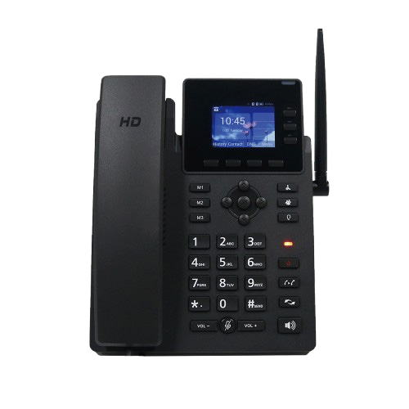

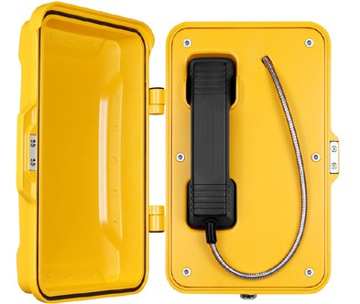
Cell phone
Cloud
Signal from the base station tower
4G Desk Telephone
Cell phone
...
JR101-CB-4G
JR101-CB-4G
JR101-CB-4G
JR101-CB-4G

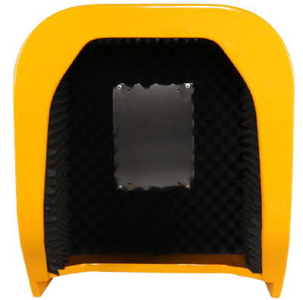
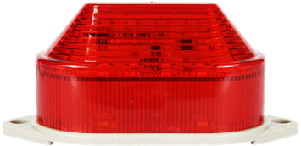
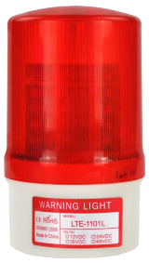
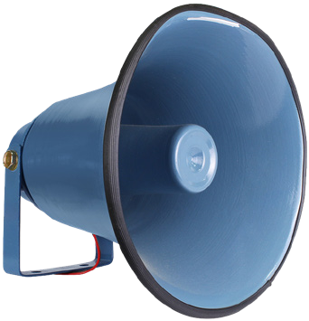
OPTIONAL ACCESSORIES
JR-LP-01
LED Light
JR-LP-02
LED Beacon Light
JR-HSA-10/20/25/30/35
Broadcast Horn
JR-TH-01
Acoustic Hood

APPLICATION SCENARIOS
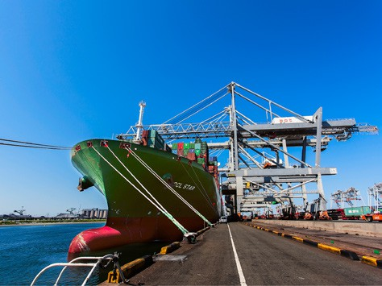

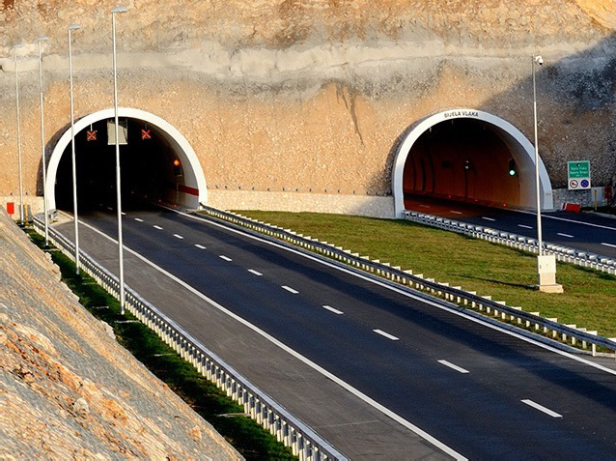


Port
Ship
Highway / Tunnel Railway

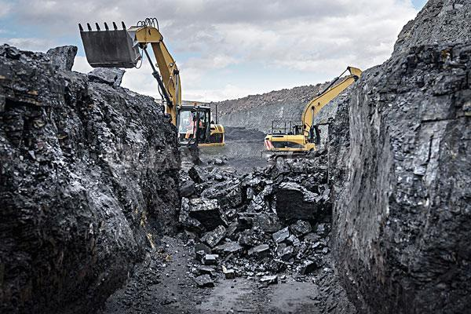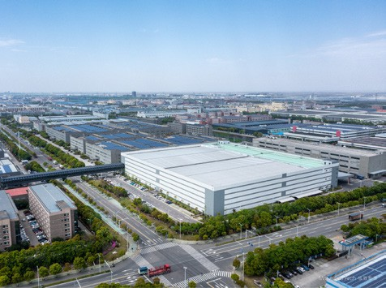

Generating station
Mining industry
Industrial park
Heavy industry

DIMENSIONS

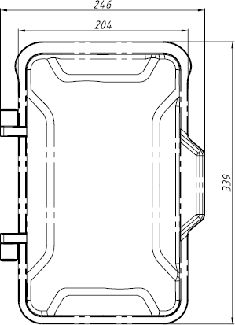
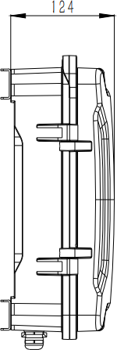
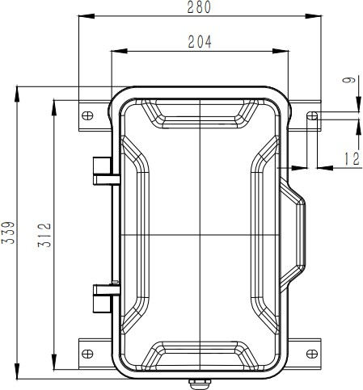
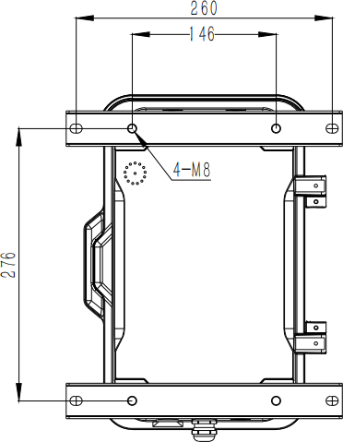

Package
Unit size | 246*339*124 (mm)
Shipping dimensions | 200*300*440 (mm)
Packaging materials | Foam padding, carton
Weight | Gross weight: 7 kg / Net weight: 6 kg


Add: 6/F, A1, Xingyi industrial city, Baishixia Est., Fuyong, Bao'an, Shenzhen, China
Email: sales@jrteck.com
Tel: +86 - 755 - 27322952
Web: www.jrteck.com

